COME JOIN US
AT CHILLY PEPPER – MIRACLE MUSTANG’S
5TH ANNUAL OPEN HOUSE
WHEN: SATURDAY, AUGUST 16, 2014
WHERE: 34694 SIDEBOTTOM RD., SHINGLETOWN CA 96088
TIME: 11:30 A.M. - ?????
COME AND SEE “YOUR RESCUE” AND WHAT “YOU HAVE ACCOMPLISHED”!
CHECK OUT THE “CHILLY PEPPER – MIRACLE MUSTANG OBSTACLE COURSE”
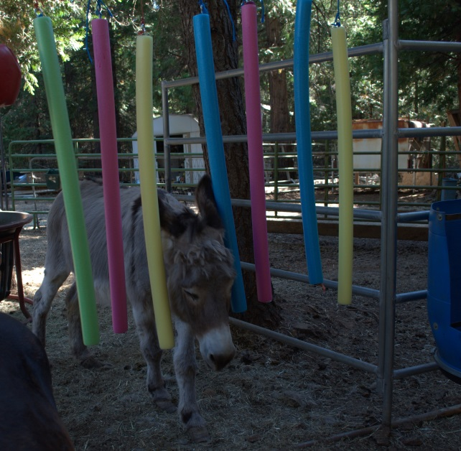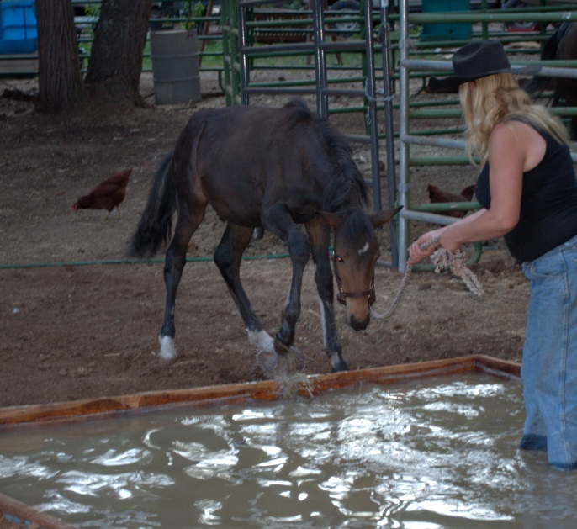
DONKEY DOING THE “INDEPENDENT STUDY” COLLINS CHECKING OUT THE WATER

CELEBRATE HONEY BANDIT’S 4RD BIRTHDAY!
THANKS TO Y’ALL – HE IS HERE TODAY!

