CHILLY PEPPER – MIRACLE MUSTANG
EQUINE RESCUE & MORE
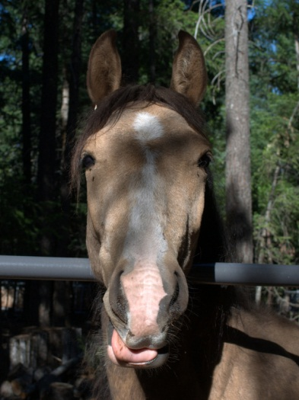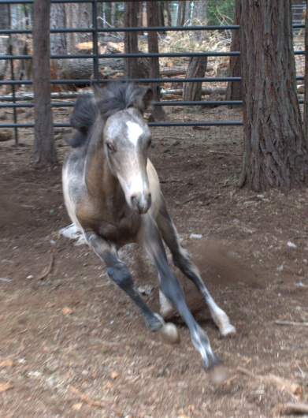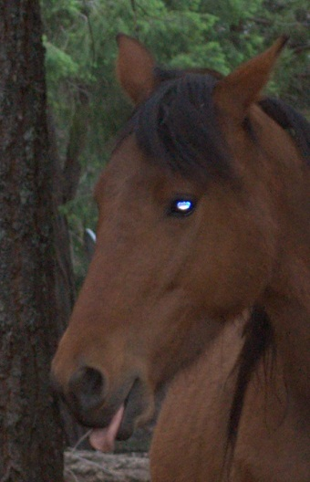

ORPHAN FOAL DIVISION
of
WHISPERING WINDS ANIMAL RESCUE

INVITES YOU TO OUR 3RD ANNUAL OPEN HOUSE !!!

WHEN: JULY 14, 2012 – 11:00 A.M. UNTIL ???

WHERE: 34694 SIDEBOTTOM ROAD
SHINGLETOWN, CA 96088

CONTACT: 530 474-5197 OR 530 339-1458 WITH ANY QUESTIONS.

FOR: A CELEBRATION OF LIFE, MIRACLES AND FRIENDSHIP.

Bring the kids, grand kids, wife, hubby, in-laws, neighbors and anyone else who might enjoy a day in the cool pines of Shingletown, CA. Come enjoy the barbeque and birthday cake and help us celebrate what ya’ll have accomplished and the lives that you have saved!

Great photo ops with the kids and the miniatures, Patches and DaBubbles, or Honey Bandit and the rest of the gang. Spend a relaxing day and beat the hot summer heat!

Our rescue would be nothing without ya’ll. Without your support, prayers and hard work, Honey Bandit and the others would not be here today, and we could not do what we do. So come and hang out and have a good time!

(Go 7 miles EAST of Shingletown and look for white sign in the trees and come on in!)

